PATIENT: ALICIA LUJAN
DOB: SEPTEMBER 10, 1972
AGE: 44
SEX: FEMALE
INSURANCE: BC/BS of SENECA

- Reason for Visit
- HPI
- Allergies
Presented to the Urgent Care with a fever and a cough. States “I have a cough that won’t go away and sometimes it is hard to breathe.” “I’m tired all the time and just don’t want to eat anything.”
Right-sided breast cancer
History of lumpectomy of right breast six months ago
History of mild depression
No Known Allergies

- Initial Visit
Purpose: To meet the patient and establish a working relationship
BP: 130/86
Temperature 101.2 Fahrenheit
Pulse 82 beats per minutes
Respirations 20
Weight: 225 pounds
Height: 5’4”
Patient reports that she is compliant in taking her medication.

- X-Ray
Chest X-ray suspicious for metastasis in the right middle lobe

- Tamoxifen
- Setraline
- OTC
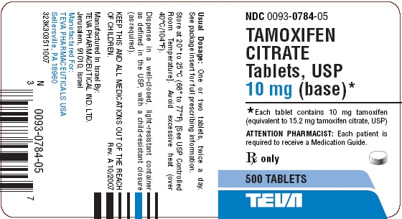
Tamoxifen 20 mg po qd
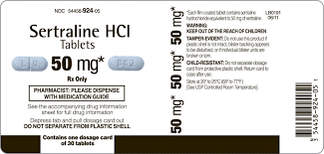
Sertraline HCL 50 mg po qd

Patient takes one St. John’s Wort capsule po for sleep when needed
Patient takes Excedrin 2 tabs po as needed.

